

email: enquiries@arnewood.hants.sch.uk

Tel: 01425 625400

www.arnewood.hants.sch.uk

READING

PASSPORT

**Reeve, Philip Here Lies Arthur \***

**Richardson, EE The Intruders**

**Riordan, Rick Percy Jackson series**

**Rose, Malcolm The Kiss of Death**

**Slater, Kim Smart**

**Smale, Holly Geek Girl series**

**Suzuma, Tabitha Without Looking Back \***

**Walter, Hon My Name’s Not Friday \***

**Robin Stevens Murder Most Unladylike series**

**Patrice Laurence Rat**

**Anthony McGowan I am the Minotaur**

**Ross Mackenzie The Nowhere Emporium**

**Arnewood English – Passport to Success**

Name: ___________________________ Tutor: ____________

Your passport can be signed by parents for each whole book you read. English teachers/the librarian will award 10 ADDS points per book read. You can earn extra ADDS for a book review/presenting a book in class.

|  |  |  |
| --- | --- | --- |
| **Parent Signature** | **Teacher Stamp / Sign** | **Book Read** |
|  |  |  |
|  |  |  |
|  |  |  |
|  |  |  |
|  |  |  |
|  |  |  |
|  |  |  |
|  |  |  |

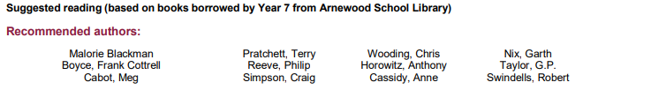

**Brittney, L Nathan Fox Series**

**Cassidy, Anne Missing Judy**

**Child, Lauren Ruby Redfort series**

**Collins, Suzanne The Hunger Games series \***

**Colfer, Eoin Artemis Fowl series \***

**Delaney, Joseph The Spook’s Apprentice series**

**Doswell, Paul Sam Witchall Series**

**Glover, Sandra Identity**

**Hutton, Sam Special Agents series**

**Landy Derek Skulduggery Pleasant series**

**Lane, Andrew Young Sherlock Holmes series**

**McKay, Hilary Casson Family Series**